**Functional Decomposition Report**

10/25/2021

By: Malichi Flemming, Tyler Owens,

Braden Priddy, Saif Wilkes-Davis

**1. Introduction**:

The purpose of this report is to identify all functions of our vision tracking system. Our team researched a variety of sources to develop a list of functions. From this list created a Functional Decomposition Diagram. Using this we created a Concept Combination Table by researching and ideating a multitude of ways to execute each function. The Concept Combination Table was then utilized to design five concepts that are applicable solutions for our product. In the coming weeks, we will assess these concepts further until we eventually single out the most practical solution. These tools are beneficial for clarifying the problems we face to develop a product that fulfils our sponsor’s missions and choosing multiple solutions to answer these problems.

**2. Product Mission**:

Create and implement a vision tracking system for a selective laser melting printer in the McNair Center. With the use of multiple cameras, the tracking system must track the melting pool and its subsequent splatters. In order to outline and display the melting pool parameters in real-time.

**3. Functional Decomposition**:

A functional decomposition breaks down the product mission into detailed functions that describe the problems that must be solved in order to build a successful vision tracking system. The functions must consist of a verb and noun that answers the question, “what must this product do,” to fulfill the product mission. Below is the detailed list of functions our team gathered for our functional decomposition.

List of Functions

1. Locate Appropriate Camera Distance and Placement
2. Move Cameras into Position
3. Stabilize Camera System
4. Protect Camera from Heat, Molten Metal Sputters and Metal Powder
5. Operator determines Best Camera Settings
6. Set Camera Settings for Optimal Image Quality

* Set Camera to Correct Light Spectrum
* Set Resolution to Meet Image Quality Needs
* Set the Camera Frames Per Second to Meet Needs of Speed of the Printer

1. Accept External Energy from Power Source
2. Power Controller, Display, and Camera
3. Boot Real Time Operating System Initiating Tracking Program
4. User Inputs Command to Begin Tracking
5. Collect, Transfer, and Store/Buffer Images of Melting Pool from Camera to Data Acquisition System or Computer
6. Process the Images
7. Measure Radius and Luminance of Melting Pool

After creating a satisfactory list of functions, a Functional Decomposition Diagram can then be crafted as seen below in Table 1.

*Table 1: Functional Decomposition Diagram* 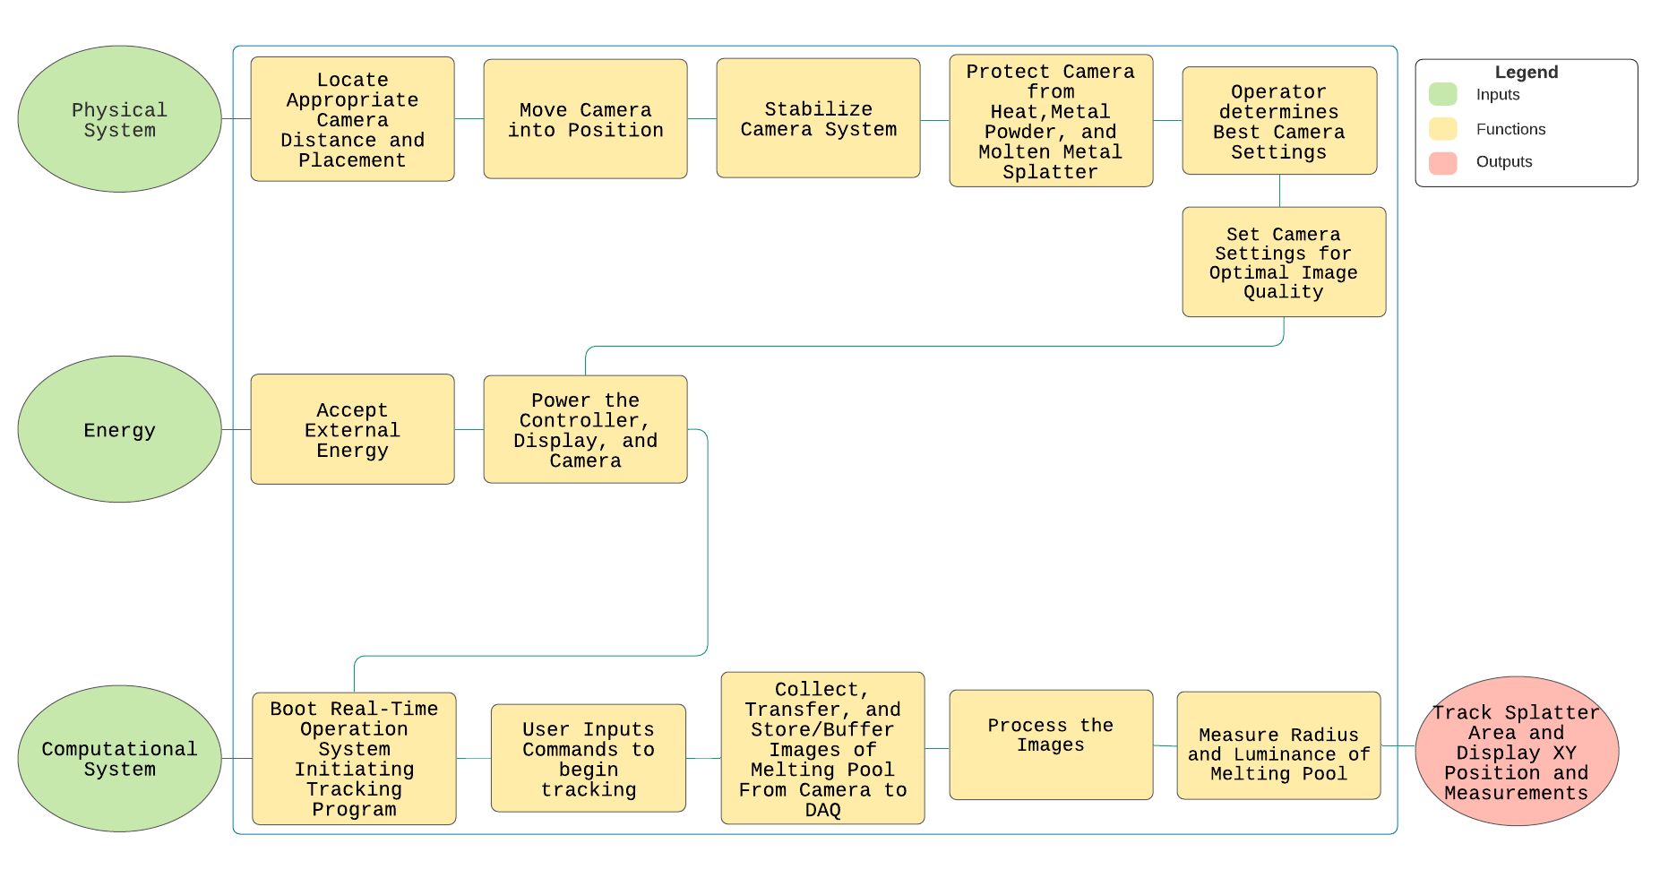

The diagram functions as a visual representation of the required actions a working product must implement to produce the desired outcome. The diagram consists of inputs, functions, and outputs, flows primarily from left to right then secondarily from top to bottom, and includes a color-coded legend for clarity. The inputs are the essential ingredients needed to build the vision tracking system and the output(s) is the desired result of the fully functioning product. The completed Functional Decomposition Diagram can then be used to create a Concept Combination Table.

**4. Concept Combinations**:

The Concept Combination Table (CCT) is a table that was generated using the functions expressed in the Functional Decomposition Diagram. The team brainstormed together to find several ways each of the functions could be delivered. This was done to help fuel ideas for the project’s concept generation phase. The team gathered ideas by researching through the internet, referring to the previously completed “Looking to Nature” assignment, and bouncing ideas off each other to formulate creative options. In Table 2, each column of the CCT consists of a heading that describes the function, and rows below contain all the feasible options that we could ascertain to carry out the function.

***Table 2:*** *Concept Combination Table*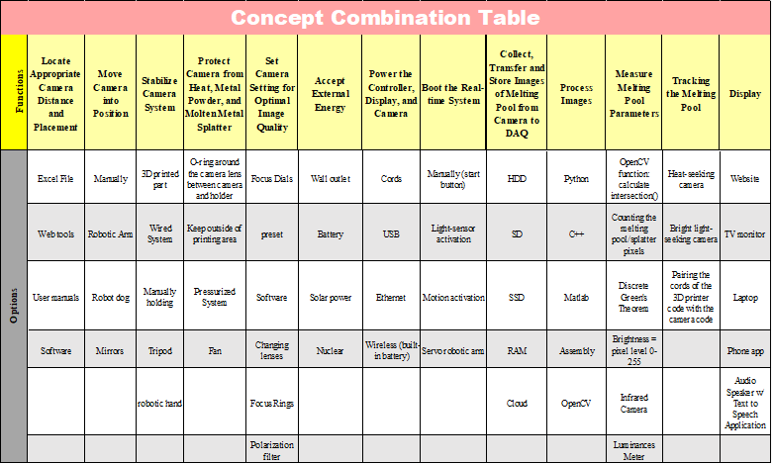

Certain functions have only one logical option to fulfill it; however, we have added additional options for the sake of brainstorming and generating ideas. Functions such as “Boot the real-time system” and “Move camera into position” will be done by hand. In principle, accumulating these ideas will assist with future design concepts.

**5. Concept Generation**:

Concepts were generated by assigning one or more options from the Concept Combination Table to each function and assembling the selected options into a viable concept. Each team member assembled four concepts each totaling sixteen concepts, and the top five concepts were chosen by vote. The following figures are illustrations of the chosen solutions along with tables listing the technologies used for each function and brief explanations of how the concepts work.

***Table 3:*** *Robot Dog Concept*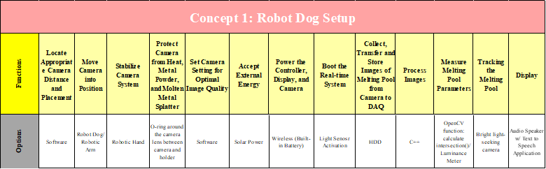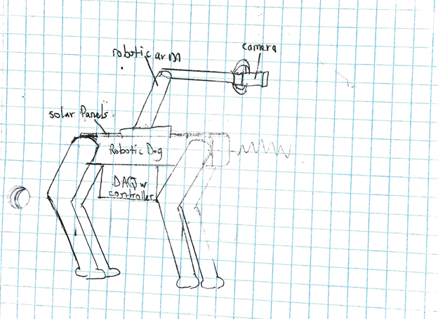***Figure 1:*** *Robot Dog Concept*

In Figure 1, the Robot Dog concept uses a Boston Dynamic type robotic dog that is powered by solar energy using solar panels placed along its back. The energy is stored in a built-in battery that also powers the controller and camera. A robotic arm with hand is attached to the top of the robotic dog to hold, stabilize, and move the camera. A bright light-sensing camera and C ++ software locates where to place the camera, sets camera settings, and processes the images. The OpenCV function, calculate intersection(), and a luminance meter records measurement, and all data is stored on a hard drive disk. Desired output data is delivered via audio speaker using text to speech application. Although the robot dog would be a creative idea, it would also would very expensive, and solar power would not be effective indoors. Table 3 shows the technology chosen for each function.

*Table 4: Python Application on Laptop with SSD and Heat-Seeking Camera Concept*

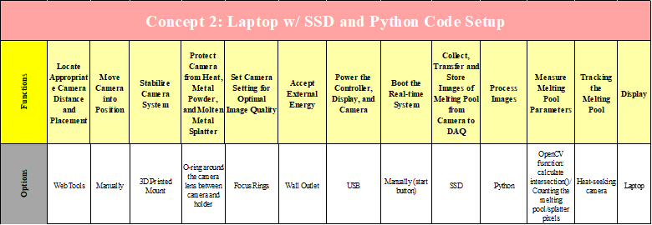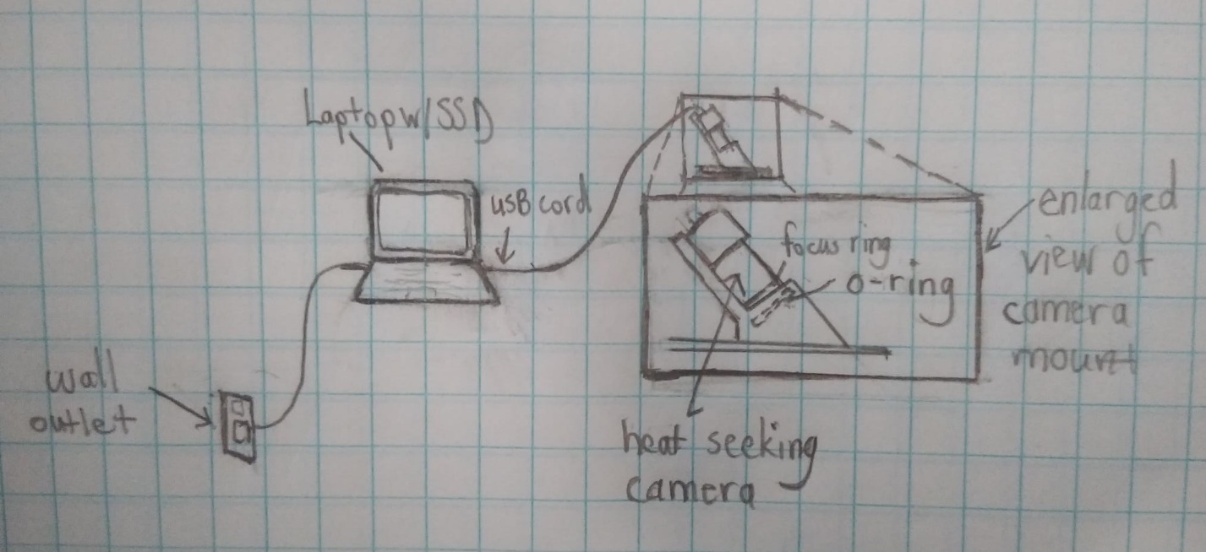***Figure 2:*** *Laptop with Solid State Drive and Python Concept*

In Figure 2, a Python application that tracks the melting pool using a heat-seeking camera will be executed on a laptop with SSD. The laptop is powered by a wall outlet and a USB cord powers the camera and enables the transfer of data from the camera to the laptop. Focus rings are manually added to focus the camera and a 3D printed camera holder with an O-ring stabilizes protects the camera. The laptop processes the data and displays the measurements on the screen. This concept would be one of the most cost efficient ideas and least complicated making it an ideal solution. Table 4 shows the technology chosen for each function.

*Table 5: Robot Arm with Camera*

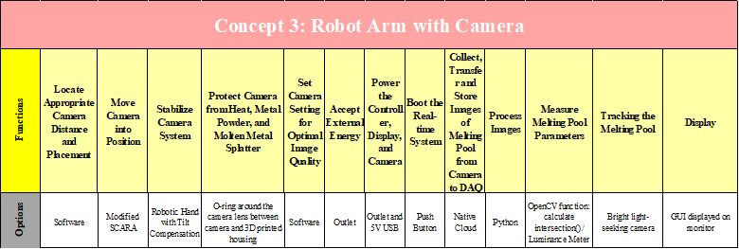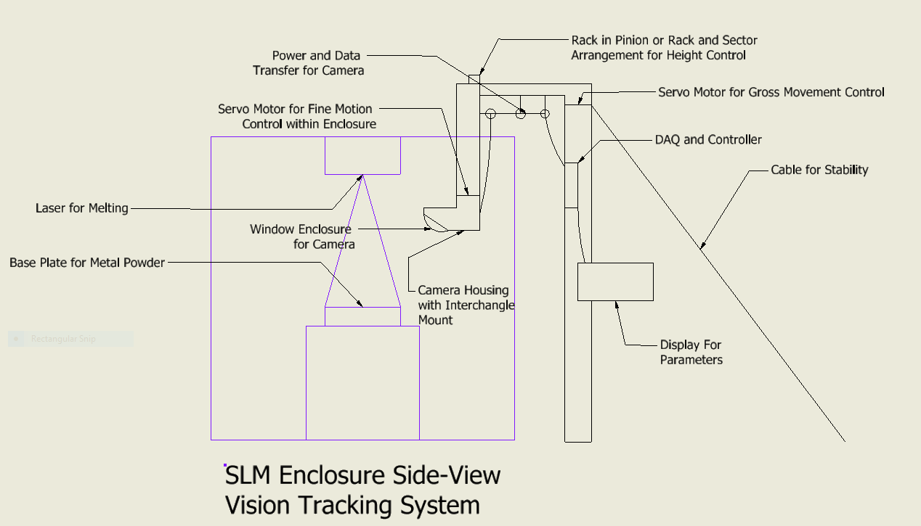

***Figure 3:*** *SCARA Variant*

In Figure 3, a robotic arm controls the positions of the camera within the enclosure. The robot arm is designed to lift outside of the enclosure to allow for easy replacement of the cameras as needed. Software will take into consideration the camera lens to determine the height needed for optimal optics. To deal with the camera shaking during movements, a cable is added to absorb some of the vibrations. A seal is formed with an O-ring and a 3D printed camera housing to protect the cameras from harm. Power is supplied to the display, controller, and motors from a 120 Volt outlet. The controller then powers the camera system. Once powered, the image will be processed in a real-time operating system running Python code. This code will track luminance to determine the melt pool position and splatter patterns.

This design is good because it can manipulate the camera into better angles than the current mounting setup. The overall set up is not expensive either. The pole could be made of PVC or wood and the motors could be harvested from equipment at either state surplus. The rest of it could be 3D printed easily. Unfortunately, the complexity of the design would add more work to the project and add cost to Dr. Downey. Additionally, it would need a secondary controller for the motor system, and we do not have much experience with motor controls on a large scale like this. Table 5 shows the technology chosen for each function.

*Table 6: Manual control of system*

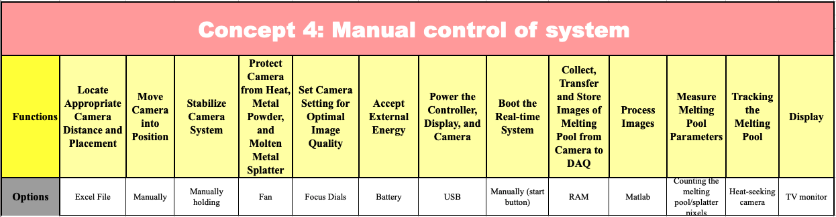

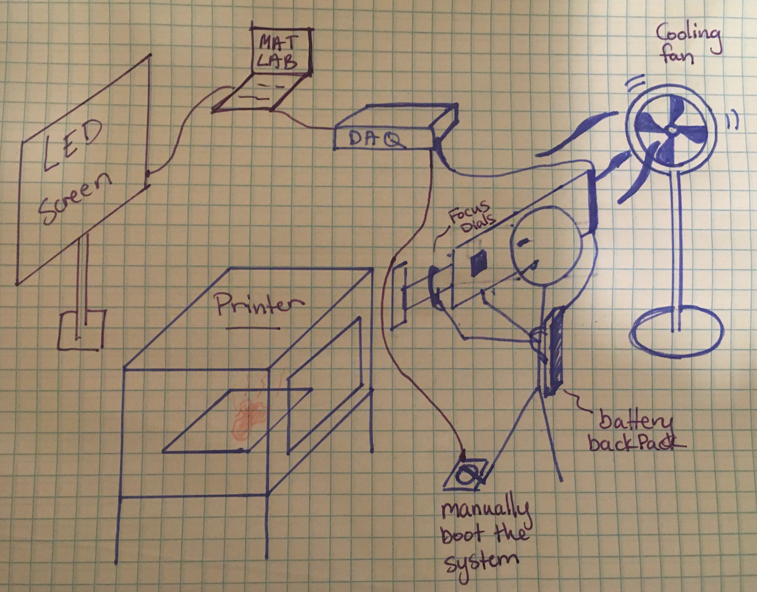

***Figure 4:*** *Manual control of system*

In Figure 4, the system is controlled primarily by the user. The camera is manually adjusted using focus dials, and the user is holding the camera in the necessary location. The camera is a heat seeking camera therefore the printer has an open area to let heat out. However, the user and the camera should not get overheated, so a fan is placed in the vicinity for cooling. The user is also wearing a battery pack that is powering the system. Data is displayed on the TV screen. This option is good for being able to control the system to the users' liking, however, that means there must always be someone there during use. Table 6 shows the technology chosen for each function.

*Table 7: Remotely viewed data*  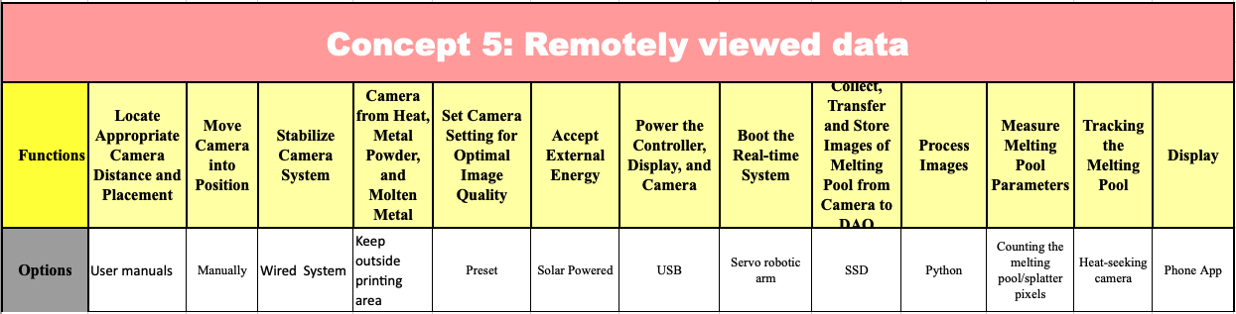

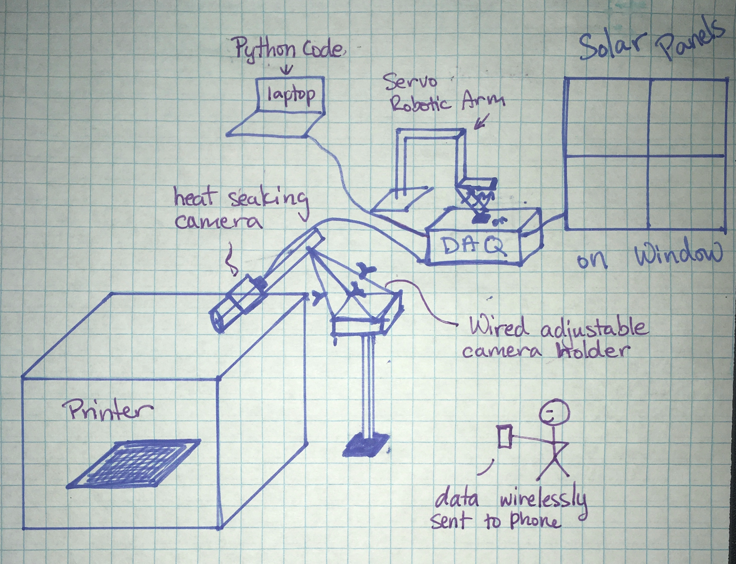

***Figure 5:*** *Remotely viewed data*

In Figure 5, the camera is setup outside the printing area and held in place using an adjustable wired setup. The system is booted using a remote-controlled servo arm and everything is powered by solar panels attached to a nearby window. The data is configured using python code and then wirelessly sent to the user’s phone via a cellphone application. The wired setup is convenient since it can be adjusted to fit the apparatus, however, having data sent wirelessly to a phone app gives opportunities for security violations. Table 7 shows the technology chosen for each function.

**6. Research performed**:

Patents have been searched for under a couple of websites - Google patents [1] and United States Patent and Trademark Office [2]. Keywords include the following:

* Metal 3-dimensional printer monitoring
* 3-dimensional printer monitoring
* 3-dimensional printer tracking
* Melting pool tracking
* Melting pool monitoring
* Monitoring of laser powder bed
* Selective laser melting
* Melting pool measurement
* Melting pool parameters
* Metal powder bed monitoring

There are a few relevant patents to consider that were found using the above keywords and that are cited in the appendix of this report. The first being the “Method and System for Monitoring Additive Manufacturing Processes” [3] which is an invention that teaches quality assurance for additive manufacturing using a multi-sensor and a real-time quality system. Similarities include using multiple optical sensors to monitor the powder bed and using a real-time operating system.

Another patent that is related to our project is one titled “Printer monitoring” [4] and is a system that monitors 3D printers using a baseline image to compare to future images taken to determine the status of the print job and alert the user of any failures. This patent is not, however, used with metal 3D printers, but collecting images to track data is similar to our project.

The last patent that was found that pertained to this project is the invention titled “Procedure and apparatus for in-situ monitoring and feedback control of selective laser powder processing” [5] which monitors and controls the Selective Laser Powder Processing by using a scanning device to follow the laser beam as well as a detector that can capture electromagnetic radiation emitted from movement on the powder surface. It also consists of an optical system to follow the laser beam.

The idea of using a camera-in-the-loop system for detecting errors during an SLM (Selective Laser Melting) process is a new idea that has been explored mostly by other universities and research groups. As such many of our ideas rely heavily upon other journals of other research groups.

# The research article “Machine-Learning-Based Monitoring of Laser Powder Bed Fusion” [6] was very constructive for our concept generation. This article is similar to what we are trying to accomplish in our project and has helped generate quite a few new options for our functions. One idea extracted from this article is the use of angled mirrors in order to get a top-down view of the metal powder bed, shown in Figure 9.

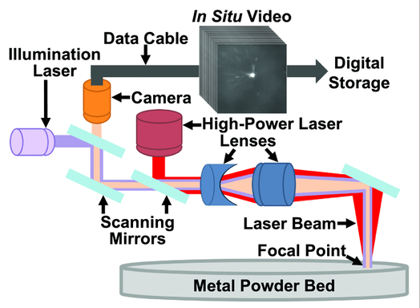

***Figure 9:*** *SLM Video Process*

This idea can drastically simplify our project in two ways. With the use of mirrors, we no longer worry about varying camera angles and positioning; effectively eliminating two of our functions (1. Locate Appropriate Camera Distance and Placement and 2. Move Cameras into Position).

One important need of the sponsor is the software aspect. We need our product to be able to track the 3D printing process and display the melting pool parameters all in real-time. This can be difficult to code completely from scratch, so we looked for other ways to simplify this process. One way we found is to use the OpenCV library [7]. Open Computer Vision, “is an open-source computer vision and machine learning software library... that provides a real-time optimized Computer Vision library, tools, and hardware [7].” OpenCV helped us come up with options for two of our functions. The first function “12. Process the Images,” is done to extract the useful information from an image by modifying it. This can be accomplished almost exclusively by OpenCV functions. The image can be processed by multiple functions like cvtColor(), GaussianBlur(), threshold(), erode(), and dilate(). All which help the code find the parameters of the melting pool. The second function OpenCV helped generate options for was, “13. Measure Radius and Luminance of Melting Pool.” As shown in Figure 10, OpenCV has a handy function called grab_contours(), which can draw a border around the melting pool.

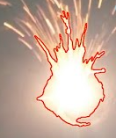

***Figure 10:*** *Contour around the melting pool*

Once this boundary is set, we can begin to calculate the melting pool’s parameters (centroid location, area, and radius).

**7. Conclusions**:

Our designs all share the requirement of our project sponsor to use existing cameras. This is important because we are running with a limited budget. Due to the nature of the printer, it is important that we protect the cameras from the heat and molten metal splatters. We all accomplished this differently, but one similarity between designs was that the camera was either outside of the printer enclosure or protected with a casing if it was inside the enclosure. We will need to determine the location needs of the camera to filter out the designs.

One design limitation for us to consider is that we will need to minimize the amount of human interaction or manual work because there is not a budget for labor. Furthermore, our team does have limited knowledge of robotics systems so avoiding complex solutions should be considered. Additionally, we should consider the security concerns of having potentially confidential images of prototypes being made.

Our potentially hardest functions to solve will be processing images or collecting and transferring of images. This is because the coding element for processing the images has been successfully done in Python but will need to be implemented in real-time. Additionally, we are having trouble getting the existing controller to run a real-time operating system and we do not have a designated budget for a new one so a cheap alternative will have to be pursued. This will also mean we will have to find drivers and other technology solutions for our existing cameras should the existing controller not work.

**8. Appendix**:

[1] <https://patents.google.com>

[2] <https://www.uspto.gov>

## [3] Vivek R. Dave, R. Bruce Madigan, Mark J. Cola, Martin S. Piltch, (2018-0619), “Method and System for Monitoring Additive Manufacturing Processes,” US20160184893A1

<https://patents.google.com/patent/US20160184893?oq=metal+3d+printer+tracking>

[4] Gregory A. Peek (2016-12-06), “Printer Monitoring”, US20160283833A1

<https://patents.google.com/patent/US20160283833?oq=3->

[dimensional+printer+monitoring](https://patents.google.com/patent/US20160283833?oq=3-)

[5] Jean-Pierre Kruth, Peter Mercelis, (2009-08-20), “Procedure and Apparatus for In-situ

Monitoring and Feedback Control of Selective Laser Powder Processing”,

US20090206065A, [https://patents.google.com/patent/US20090206065? q=monitoring+of+laser+powder+bed](https://patents.google.com/patent/US20090206065?%09%09%09%09q=monitoring+of+laser+powder+bed%20)

[6] <https://onlinelibrary.wiley.com/doi/full/10.1002/admt.201800136?>

[casa_token=CiGQAkBohNkAAAAA%3AwweIp5Q8BWn6dAMl0ncqNZaeaCLheuDcU 06z69ZI6K2QFvijpGtvxmn8ljxIm7Crivt_02LpJw_5beTzgA](https://onlinelibrary.wiley.com/doi/full/10.1002/admt.201800136?)

[7] <https://opencv.org/about/>

## 